Inclusion, Special Educational Needs and Additional Support Policy
2023/24
Contents
Introduction Statement 2
School Information 2
Belief Statement 2
Rationale 2
Aims 3
Objectives 3
Principles Underpinning the Implementation of Guidelines for Primary Schools (2017) 3
Identifying Children with additional needs 4
Information Gathering and Assessment 6
Assessment and Screening Tests 7
Inventory of Test Materials 7
Prevention and Early Intervention Strategies 8
Meeting the Needs and Allocating resources 9
The selection process for allocating additional teaching support 10
Timetabling 11
Roles and responsibilities 11
Tracking, recording and reviewing progress 15
SEN records 18
Communication 18
Communication Diaries 19
Regulation 19
Arrival and Dismissal of Children with Additional Needs 19
Process when receiving Newcomer Children 19
Process when receiving children with additional needs 19
Health and Safety Issues 19
Supervision /Child Protection 20
Working with external agencies, professionals, and parents 20
Other Policies 23
Special Needs Assistants (SNAs) Policy and Guidelines 23
Ratification and Communication 30
Appendix 1: Flow Diagram – Classroom Support (Stage 1) 31
Appendix 2: Flow Diagram – School Support (Stage 2) 32
Appendix 3: Flow Diagram – School Support Plus (Stage 3) 33

Introduction Statement
Scoil Nioclás Naofa (Dunmore NS) is committed to creating an inclusive environment where the individuality of all pupils is valued and celebrated. We are committed to giving all pupils every opportunity to achieve the highest of standards. We do this by taking account of pupils' varied life experiences and needs. We offer a broad and balanced curriculum and have high expectations for all children. The achievements, attitudes and wellbeing of all our pupils matter. This policy helps to ensure that this school promotes the individuality and full inclusion of children with special educational needs (SEN) and/or disability in the life of the school.
The policy was fully reviewed and amended in 2018, to take account of Department of Education (DE) Circular 13/2017 ('Special Education Teaching Allocation') and the accompanying updated guidelines entitled, 'Guidelines for Primary Schools Supporting Pupils with Special Educational Needs in Mainstream Schools' (2017). In 2022/23, a review of the policy was conducted to reflect the changes in the school to be reflective of current practice and update in 2023/24.

School Information
Scoil Nioclás Naofa (Dunmore NS) is a Catholic, child-centred, co-educational, democratically-run primary school in north county Galway. We have eight mainstream classes and operate under the patronage of the Archdiocese of Tuam. We endeavour to create a positive and inclusive atmosphere that respects all children, regardless of their religious, social, cultural or family background or SEN. Our current allocation of Special Education Teachers (SETs) is 82.50 hrs - 3 full-time and a shared post based at Gortnaleam (5hrs) and 2.5 hours banked a week. We are in receipt of additional language hours. In 2023/24, we have one fixed-term EAL position.

Belief Statement
The ethos of our school is Catholic and Christian. It is based on the Christian philosophy of society in Ireland. We have our set of values that tell us that each pupil is created in God’s image, that he/she has a life to lead to the best of his/her ability and a soul to be saved. We believe that all children are equal in God’s eyes and each is entitled to an equal chance of obtaining optimum personal fulfilment. We equally recognise and respect the diversity of beliefs, values and aspirations of all religious, ethnic and cultural groups in our community. Our school will be a very important agent along with the home, the Church and the community in the development of each child. Every effort will be made to ensure that the child’s all-around development is healthy and harmonious.

Rationale
Our school aims to be an inclusive school for all children and families, including for those with SEN and/or disability. We actively seek to remove the barriers to learning and participation that can hinder or exclude individual pupils or groups of pupils. The purpose of this policy is to underline some of the processes in place to do this.

Aims
The aims of this policy are to:
- Provide practical guidance to staff, parents/guardians and other concerned persons on the provision of effective support to pupils experiencing or likely to experience learning difficulties.
- Describe the continuum of support for addressing additional needs in this school
- Fulfil our obligations under the Education Act 1998, Education and Welfare Act 2020 and Disability Bill 2002.
- Outline how this school has implemented DE Circular 13/2017 and the updated Guidelines for Primary Schools: Supporting Pupils with Special Educational Needs in Mainstream Schools (2017).

Objectives
The objective of this policy is to outline the procedures and practices for how we:
- Identify additional needs that our pupils may have;
- Allocate resources to effectively meet the needs of children with additional needs;
- Divide the roles and responsibilities among our school community in relation to pupils with additional needs;
- Track, monitor, review and report on the progress of children with additional needs;
- Communicate information between the SET team, principal, staff and parents/guardians.

Principles Underpinning the Implementation of Guidelines for Primary Schools (2017)
This policy supports the principles as laid out in the SEN guidelines (2017):
- Resources provided to support pupils with special educational needs should be used to facilitate the development of truly inclusive schools.
- Supports provided to pupils with special educational needs should be based on identified needs and be informed by regular reviews of progress (in consultation with parents and pupils) as outlined in the Continuum of Support Guidelines.
- The class teacher has primary responsibility for the progress and care of all pupils in the classroom, including pupils with special educational needs.
- Special education teaching supports provided to schools should be used solely for the support of pupils with identified special educational needs, including those pupils for whom English is an Additional Language (EAL). The special education teaching supports cannot be used to reduce the pupil-teacher ratio in mainstream classes. Neither can they be used to allow any special education teacher sole responsibility for the delivery of any curriculum subject to any particular class.
- Pupils with the greatest levels of need should have access to the greatest level of support, and whenever possible, these pupils should be supported by teachers with relevant expertise who can provide continuity of support.
- Schools with more than one support teacher should establish and maintain a core team of teachers to meet the needs of pupils with special educational needs. All members should have the necessary experience and access to continuing professional development to support the diverse needs of pupils with special educational needs.

Identifying Children with additional needs
Continuum of Support
We use the Continuum of Support framework set out by the Department of Education to identify and support children with additional needs. Like this framework, we recognise that special educational needs occur along a continuum, ranging from mild to severe, and from transient to long-term and that pupils require different levels of support depending on their identified additional needs. By using this framework, it helps us implement a staged approach to ensure that our support and interventions are incremental, moving from class-based interventions to more intensive and individualised support, and are informed by careful monitoring of progress.
The Continuum of Support is a problem-solving model of assessment and intervention that enables us to gather and analyse data, as well as to plan and review the progress of individual pupils. This problem-solving process is illustrated in Figure 1

Figure 1: Continuum of Support Problem-Solving Process
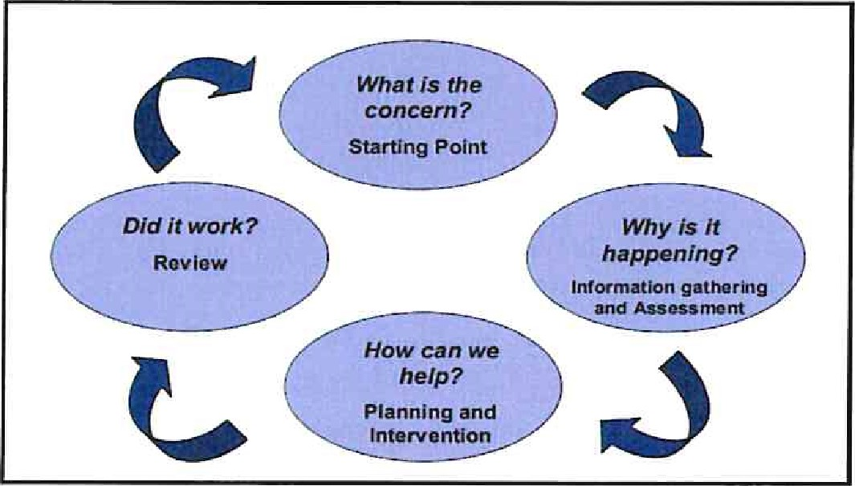
Identification of special educational needs is central to our policy and the allocation model. By using the Continuum of Support framework, we can identify pupils' educational needs, including academic, social and emotional needs, as well as needs associated with physical, sensory, language and communication difficulties. This, in turn, allows us to identify and respond to needs in a flexible way. The Continuum of Support recommends the support levels as illustrated in Figure 2.
Figure 2: Levels on Continuum of Support
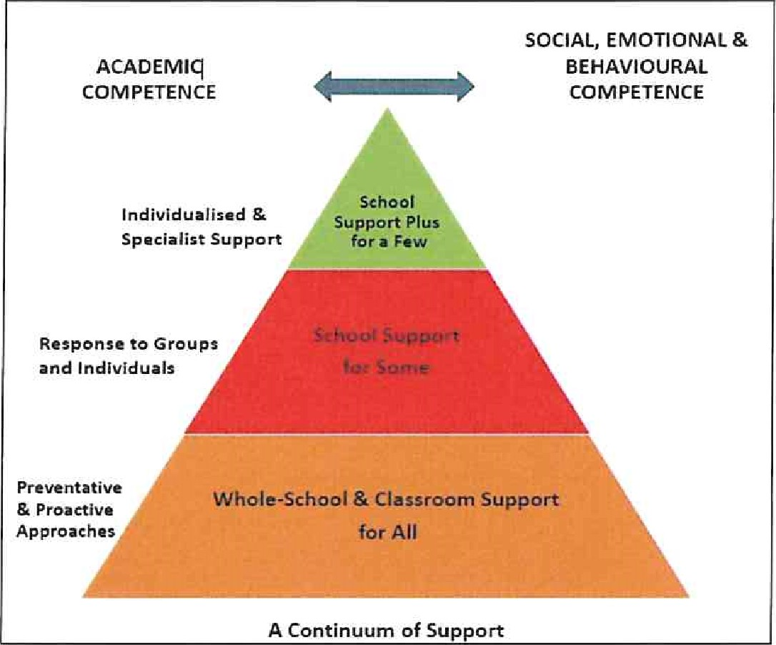
STAGE 1 - CLASSROOM SUPPORT
Classroom Support is the most common, and typically the first response to emerging needs. It is a response for pupils who have distinct or individual educational needs and who require approaches to learning and/or behaviour which are additional to or different from those required by other pupils in their class. Problem-solving at this level typically begins when a parent or teacher has concerns about an individual pupil. The teacher and parents discuss the nature of the problem and consider strategies which may be effective. Classroom Support incorporates the simple, informal problem-solving approaches commonly used by class teachers to support emerging needs.
In all classes, teacher observation plays a crucial role in early intervention. It is the policy in our school that all teachers would use the template mentioned above.
The comprehensive set of checklists will allow the teacher to begin recording formally her observations on the child as regards health, relationships and responses to the school learning environment. The Support File will contain a Support Plan and a Support Review Record.
STAGE 2 - SCHOOL SUPPORT
In some cases, interventions at classroom support level are not enough to fully meet the pupil's special educational needs. School Support may, therefore, be required. The class teacher needs to involve the Special Education Teacher (SET ) in the problem-solving process at this point and it involves more systematic gathering of information and the development and monitoring of a School Support Plan.
Should difficulties persist, and following consultation with special education teachers, principal and parents some pupils may require further more intensive intervention. The child will then move to the School Support stage where a pupil will receive additional help, either on a one to one basis, or as part of a group from the Special Education Team.

STAGE 3 - SCHOOL SUPPORT PLUS
If a pupil's special educational needs are severe and/or persistent, they are likely to need intensive support. School Support Plus will generally involve personnel outside the school team in the problem solving, assessment and intervention process. However, the information from Classroom and School Support work will provide the starting point for problem-solving at this level. Classroom support and school support will continue to be an important element of his/her school support plan.
The flow diagrams (Appendix A, B and C) outline how we gather information to identify needs and support children with additional needs. A more comprehensive explanation of each stage can be found in the Continuum of Support — Guidelines for teachers: https :(/www.education.ie/en/Schools-Colleges/Services/National-EducationalPsycholoqical-Service-NEPS-/neps special needs quidelines.pdf
Those pupils who have significant special educational needs arising from high or low-incidence disabilities, and who have been assessed previously are considered to be at stage 3 of intervention. In short, stage 3 involves a specific learning programme e.g. phonics, basic numeracy, speech and language, etc tailored to the need of the individual pupil and implemented by one of the special education team either on a one-to-one basis or within a group.
Children who have been assessed will require a Student Support Plan. This document must be a “Whole Child Document” which provides a comprehensive overview of the development of the child to date. A Student Support Plan should:
- Provide a comprehensive profile of a child.
- Provide a structure for future learning.
- Be based on a continuum of support.
- Be a working document, updated regularly.
- Provide day-to-day advice.
- Be formulated in October and have a final review date in May.
- Be practical and realistic in its approach.

What Will Be in The Student Support Plan?
It is the policy of Scoil Nioclás Naofa that each child who has been assessed will have an IEP which will contain information about:
- The pupil’s strengths and needs.
- The pupil’s current level of performance.
- The pupil’s priority learning needs. (Maximum of 3).
- Targets (SMART).
- Resources and personnel involved.
- The implementation of the plan.
- Date of review.

Information Gathering and Assessment
Assessment is part of what a class teacher does on a daily basis for all children. Some methods include self-assessment, questioning, teacher observation, portfolios of work and teacher-designed tasks and tests. The information gathered enables the teacher to plan learning experiences based on the appropriate objectives from the curriculum.
In order to identify pupils who may require supplementary teaching, screening; including standardised testing, is carried out in all classes annually in May and further diagnostic testing may need to take place. The information gathered from these formal assessments is then used to inform decisions for support and pupils’ support plans.

Assessment and Screening Tests
In our school we carry out the following assessment procedures:
- Junior Infants: Self-assessment, Observation, Checklists, teacher-designed sound tests, seasonal maths assessments BIAP (on all pupils).
- Senior Infants: Self-assessment, Observation, Checklists, MIST, teacher-designed word and sound tests, seasonal maths assessments.
- 1st class: Self-assessment, Observation, Checklists, Drumcondra Early Literacy Screening, Drumcondra Early Numeracy Screening, Drumcondra Primary Spelling Test.
- 2nd class: Self-assessment, Observation, Checklists, Early Literacy Index.
- 3 ^{rd} class: Self-assessment, Observation, Checklists, Drumcondra Primary Reading Test, Drumcondra Primary Spelling Test Drumcondra Primary Maths Test.
- 4th class: Self-assessment, Observation, Checklists, Drumcondra Primary Reading Test, Drumcondra Primary Spelling Test, Drumcondra Primary Maths Test,
- 5th class: Self-assessment, Observation, Checklists, Drumcondra Primary Reading Test, Drumcondra Primary Spelling Test, Drumcondra Primary Maths Test.
- 6th class: Self-assessment, Observation, Checklists, Drumcondra Primary Reading Test, Drumcondra Primary Spelling Test, Drumcondra Primary Maths Test.
We continually review the assessment and screening tests used in order to balance the needs of our pupils and the need to provide information for appropriate support, therefore, we may deviate from the above list prior to the review date.

Inventory of Test Materials
Screening Tests
In our school the following screening tests are available for administration:
- Belfield Infant Assessment Profile (BIAP)
- Middle Infant Screening Test (MIST)
- Drumcondra Test of Early Literacy - Screening ( DTEL-S)
- Drumcondra Primary Reading Test (DPRT)
- Drumcondra Primary Spelling Test (DPST)
- Drumcondra Primary Maths Test (DPMT)
- Drumcondra Test of Early Numeracy - Screening ( DTEN-S)

Diagnostic Tests
In our school the following diagnostic tests are available for administration:
- Jackson Phonics Test
- British Vocabulary Scales
- RAIN Sentence Reading Test
- Quest Literacy and Maths tests
- Two peas Phonological Awareness assessment
- Maths Recovery screening tests
- Non-Word Reading Test
- Single Word Spelling Test

Prevention and Early Intervention Strategies
Our prevention and early intervention strategies include:
- The development of agreed approaches to the teaching of Literacy and Numeracy in order to ensure progression and continuity from class to class;
- Provision of additional support in language development and any relevant early literacy and mathematical skills to pupils who need it;
- Ongoing structured observation and assessment of the language, literacy and numeracy skills of pupils in the infant classes to facilitate early identification of possible learning difficulties;
- Close collaboration and consultation between the Infant Teacher and the SET team
- Promotion of literacy e.g. Print-rich environment, Literacy Hour, Shared Reading;
- Promotion of Numeracy e.g. Ready Set Go Maths, Hands-on approach, Maths Games;
- Parental involvement in promoting literacy and numeracy;
- Homework Policy Guidelines for Parents;
- Differentiation adapting the learning environment;
- In-class support from the SET team;
- Literacy Hour / Team Teaching / Aistear / Guided Reading;
- Withdrawing individuals/groups;
- Building Bridges to Comprehension Strategies;
- Jolly Phonics programme (Juniors — 6th );
- Systematic approach to genre writing throughout the school;
- Systematic approach to spoken text types throughout the school;
- Where problems in language skills, motor skills, and mathematical competency seem to be emerging, it may be necessary for early screening of the child by outside agencies, subject to parental approval. Many children will already be undergoing a programme of language development under the guidance of speech therapists. It is school policy that our learning support team will implement any structured programme in all classes;
- In all cases, the role of the class teacher is paramount where his/her professional judgement based on observation is often the critical factor in the initial stages of identifying children who need help to develop their phonological awareness.

Meeting the Needs and Allocating resources
Once pupils’ needs have been identified, Special Education Teachers (SETs) are deployed to address these needs as required. The deployment of Special Education Teachers is at the discretion of the principal and the deployment may be subject to change throughout the academic year. The Principal and SEN Coordinator meet regularly to discuss the deployment and tweak arrangements where necessary. We deploy SETs in a variety of ways in order to effectively meet pupils' needs. We aim to strike a balance between in-class support, and group and individual support while ensuring that the needs of children with additional needs are met inclusively. We also try to minimise disruption to classes by allocating SET teachers to classes to cater for all the needs in that particular class. A breakdown of the teaching duties for the SET team will be compiled by the SEN Coordinator and kept in the Principal's Office for review.
Importantly, the level and type of support reflect the specific targets of individual pupils as set out in their support plans and are informed by careful monitoring and review of progress. In this way, following a period of intervention, some pupils may no longer require additional teaching support; some may require the same level, while others may require more intensive support.
In planning the allocation of additional teaching supports, the overriding principle is that resources are deployed to address the identified needs of pupils. Importantly, those with the highest level of need should have access to the greatest level of support. We consider methodologies best suited to promoting meaningful inclusion such as differentiation, heterogeneous grouping, team teaching and small group teaching. In addition to literacy and numeracy difficulties, many pupils will have specific needs in such areas as oral language, social interaction, behaviour, emotional development, motor skills and application to learning.
At the end of every term each SET meets the class teachers that they are allocated to and reviews the children’s needs, the resources in place and the progress made using the Continuum of Support problem-solving model of assessment and stage approach flow charts. Each SET then brings this information to the end-of-term SET team planning meetings. As a team, SETs and the principal review all support and allocate resources for the subsequent term. We cross-reference the needs of pupils at School Support and School Support Plus levels and consider common needs that can be met by grouping, to ensure effective and efficient teaching and learning approaches.

The selection process for allocating additional teaching support
Stage 3 (School Support Plus) | - Children with identified complex needs which are significant and enduring as diagnosed by a health professional:  - Autistic Spectrum Disorder  - Physical Disability  - Hearing Impairment  - Visual Impairment  - Emotional Disturbance  - Moderate General Learning Disability  - Assessed Syndrome  - Specific Speech and Language Disorder/Impairment | Individual Education Plans | Type of Support  In-class support  Team-teaching  Group Withdrawal  Individual  Withdrawal  Personnel  Class Teacher  SET teacher  SNA  Outside agencies
Stage 2 (School Support) | ** The principal reserves the right to offer support to any child who they deem to need immediate support.  - Prevention and Early Intervention Programs;  - Children with English as an additional language – for the length of time that we are in receipt of extra EAL hours;  - All children who scored at or below the 10th Percentile Rank Sten 3, in literacy, at or below 84 standard score in the DMPT-Level1S and at or below 57 standard score in the Early Drumcondra.  - Junior Infants whose BIAP scores indicate a need for intervention at a later stage in Senior Infants.  - Senior Infants whose MIST tests scores indicate their need for further intervention.  - Children who are historically low achievers in the school but who may be just above the 10th Percentile, at or below 84 standard score in the DMPT-Level1S and at or below 53 standard score in the Early Drumcondra.  - When all children who fall within the above range are taken into consideration, the question of learning support in Mathematics will also be considered.  - Children in the low incidence and high incidence categories make up the bulk of those who will receive additional help. Other children will receive additional help as resources allow.  - Children who have not made adequate progress after interventions at stage 1  - Children who have not made adequate progress after EAL interventions.  - Children with an identified need assessed by external professionals who are not on or below the 10th percentile in literacy such as:  - Borderline Mild General Learning Disability  - Mild General Learning Disability  - Specific Learning Disability  - Attention Deficit Disorder/ Attention Deficit Hyperactivity Disorder  - Children with an identified need assessed by external professionals who are not on or below the 10th percentile in numeracy such as:  - Borderline Mild General Learning Disability  - Mild General Learning Disability  - Specific Learning Disability  - Attention Deficit Disorder/ Attention Deficit Hyperactivity Disorder | Group or Individual Profile and Learning Programme | Type of Support  In-class support  Team-teaching  Group Withdrawal  Individual  Withdrawal  Personnel  Class Teacher  SET teacher  SNA

Timetabling
When drawing up timetables we recognise the following:
- Timetables should be continually reviewed
- Children should not miss the same subject each time they are withdrawn
- If a pupil is unavailable for their supplementary session due to special circumstances, the SET will attempt to reschedule the session with the cooperation of another teacher
- Interruptions to classes/classrooms should be kept to a minimum.

Roles and responsibilities
BOARD OF MANAGEMENT
The Board of Management will:
- Oversee the development, implementation and review of school policy on SEN
- Ensure that adequate classroom accommodation, secure storage space and effective teaching resources are provided
- Support on-going professional development for all staff around special education and inclusion.
PRINCIPAL
The Principal Teacher will undertake the responsibilities associated with special education provision, listed in p. 23 of the Guidelines for Primary Schools Supporting Pupils with Special Educational Needs in Mainstream Schools (2017). These include:
- Lead the development of inclusive whole-school policies and monitor their implementation
- Assign staff strategically to teaching roles, including special education teaching roles
- Co-ordinate teachers' work to ensure continuity of provision for all pupils
- Ensure that whole-school procedures are established to facilitate the effective involvement of parents, pupils and external professionals / agencies
- Ensure that effective systems are implemented to identify pupils' needs and that progress is monitored methodically
- Facilitate the continuing professional development of all teachers in relation to the education of pupils with special educational needs, and ensure that all school staff (class teachers, special education teachers and special needs assistants) are clear regarding their roles and responsibilities in this area
The Board of Management of Scoil Nioclás Naofa (Dunmore NS) fully endorses and nurtures the culture of distributed leadership recommended in Circular 44/2019 and the Quality Framework for Leadership and Management in Irish schools, set out in Looking at Our School (2022). To this end, the Board recognises that the Principal Teacher will delegate some of the abovementioned actions to other members of staff (e.g. member of the In-School Leadership Team, Special Education Team, Class Teacher etc.) while retaining overall responsibility for the school's provision for pupils with SEN. This approach is in accordance with p.23 of the above-referenced guidelines.
SPECIAL EDUCATIONAL NEEDS COORDINATOR
The SEN Coordinator Scoil Nioclás Naofa (Dunmore NS) is a member of the In-School Leadership (ISL) Team and, as such, in accordance with Circular 44/2019, provides an annual report to the BOM on his/her ISL-related responsibilities. These responsibilities are reviewed on an annual basis to respond to emerging need but will include:
- Communicating with the principal in relation to SEN matters on an on-going basis
- Liaising with external agencies about the provision for pupils with SEN
- Liaising with the principal, NEPS psychologist, the SET team and class teachers to prioritise children for psychological assessments (NEPS)
- Liaising with SET's to identify, support and monitor children with SEN
- Coordinating regular SET team planning meetings to ensure effective communication and support for children with additional needs
- Collaborating with the SET team in creating timetables for additional support
- Meeting with parents regarding any concerns about their child, advise parents on procedures for availing of special needs services and update them regarding their progress
- Coordinating the whole-school standardised testing at each class level
- Coordinating the screening of pupils for additional support, using the results of standardised tests
- Working with teachers to identify children for external diagnostic assessment, where parental permission has been sought and granted
- Overseeing the tracking system of test results on password-protected Aladdin software to monitor the progress of pupils
- Overseeing the compilation of the Continuum of Support register of pupils
CLASS TEACHERS
Class teachers have primary responsibility for the teaching and learning of pupils in his/her class, including those selected for additional support, They should:
- Implement teaching programmes which optimise the learning of all pupils and to the greatest extent possible, prevent the emergence of learning difficulties
- Create a positive learning environment within the classroom
- Differentiate teaching strategies, approaches and expectations to the range of experiences, abilities, needs and learning styles in their class
- Administer and correct standardised tests of achievement in literacy and numeracy, following the school's guidelines
- Discuss outcomes of standardised testing with SETs to assist in the selection of children for supplementary teaching
- Meet with parents regarding any concerns about their child and update them regarding their progress
- Gather information and assess children presenting with needs to inform teaching and learning using the Continuum of Support
- Open a Pupil Support File once additional needs have been identified and require classroom support
- Develop classroom support plans for children in receipt of Classroom Support
- Meet with SETS, parents/guardians and other staff members to identify priority learning goals for each pupil in receipt of School Support Plus and who require an Individual Education Plan
- Collaborate with Special Education Teachers and relevant staff to develop a Support Plan for each pupil in receipt of School Support Plus
- regularly meet with Special Education Teachers, relevant staff to review School Support Plans
- Meet regularly with SETS, relevant staff and parents to review School Support Plans
- Where applicable, collaborate with the SET team regarding teaching aims and activities for team teaching
- Adjust the class timetable to ensure that children in receipt of supplementary teaching will not be absent for the same subject/activity during each session
- Co-ordinate the role and responsibilities of the SNA in relation to the needs of pupils with SEN within the class(es) to which they are assigned

SPECIAL EDUCATION TEACHERS (SET)
Special education teachers in Nioclás Noafa (Dunmore NS) are familiar with a wide range of teaching approaches, methodologies and resources to cater for particular learning styles and to meet a variety of needs. In this school they should:
- Assist in the implementation of a broad range of whole-school strategies aimed at prevention and early intervention
- Collaboratively develop a Support Plan for each pupil selected for school support teaching with class teachers and other staff
- Meet with class teachers, parents/guardians and other staff members to identify priority learning goals for each pupil in receipt of School Support Plus and who require a School Support Plus plan (SSP)
- Collaborate with class teachers and relevant staff to develop a School Support Plus Plan for each pupil in receipt of School Support Plus
- Regularly meet with class teachers and relevant staff to review school support plus plans
- Meet twice a year with class teachers, relevant staff and parents to formally review SSP
- Update and maintain planning and progress records for each individual or group of pupils in receipt of school support
- Provide supplementary teaching for literacy and numeracy on a withdrawal and in-class support basis
- Support whole-school procedures for screening
- Administer / interpret diagnostic tests and inform class teachers parents of the outcomes
- Meet with parents regarding any concerns about their child and update them regarding their progress
- Co-ordinate class groups and offer advice and support to class teachers regarding pupils on their caseload
- Discuss the needs and progress of children on their caseload at planning meetings
- Provide necessary information to a pupil's receiving school once a transfer letter has been received
- Coordinate the whole school standardised testing at each class level.
- Co-ordinate the screening of pupils for additional support, using the results of standardised tests
- When requested by the class teacher, meet parents to discuss moving a child from classroom support to school support or when referring to an outside agency

SPECIAL NEEDS ASSISTANTS
The duties of the Special Needs Assistant (SNA) are carried out according to the guidelines for Special Needs Assistants from the Department of Education and under the direction of the principal/class teachers. In this school the SNA will meet the care needs of the pupils to which they have been assigned and should:

- Support the needs of pupils in effectively accessing the curriculum
- Contribute to the quality of care and welfare of the pupils
- Feed into a child’s Support Plan
- Support learning and teaching in the classroom
- Attend, where possible, training courses/workshops provided by the BOM
- Attend meetings with relevant professionals, when necessary
- Ensure the safety of the SEN pupils in the schoolyard, and be present for the duration of the yard breaks along with the teachers on duty
- Maintain a record of support provided to their SEN pupil
- Accompany SEN pupil to supplementary lessons when appropriate

PARENT(S) AND/OR GUARDIAN(S)
Collaboration and sharing of relevant information between home and school are essential elements of our SEN policy, Parents/Guardians through their unique knowledge of their own children have much to contribute to their child's learning. To this end Parent(s)/Guardian(s) should:

- Share any information, reports or reports pending from health professionals, and/or concerns regarding their child's development. Copies of professional reports should be provided to the school at the enrolment stage
- Support the work of the school and keep the class teacher informed of the progress and challenges they observe in their child's learning
- Attend meetings arranged by the class teacher or SET team
- Support the targets outlined in their child's support plans and engage in all suggested home-based activities
- Inform the post-primary school of their child's needs, at the transition stage

PUPILS
Pupils’ voice is very important to us in Scoil Nioclás Naofa (Dunmore NS). Pupils are consulted on what they believe their strengths and aspects for improvement are. Pupils in receipt of supplementary teaching should, as appropriate:
- Be given the opportunity to contribute to the setting of the medium and short-term learning targets
- Become familiar with the targets that have been set for them
- Develop 'ownership' of the skills and strategies that are taught during supplementary teaching and learn to apply these learning strategies and skills to improve their own learning
- Contribute to the evaluation of their progress by participating in appropriate assessment activities, including self-assessment

Tracking, recording and reviewing progress
Provision for pupils with special educational needs is enhanced through clear identification processes and careful planning of interventions to address academic and/or personal and social development needs. Identification of needs, planning, target-setting and monitoring of outcomes are essential elements of an integrated and collaborative problem-solving process.
STUDENT SUPPORT FILE
We use a Student Support Fife to plan interventions and to track a pupil's pathway through the Continuum of Support. It facilitates us in documenting progress and needs over time and assists us in providing an appropriate level of support to pupils, in line with their level of need. Our Student Support File is based on the NEPS template and is stored on Aladdin (school administration system). All support files should include:
- Cover sheet with pupil's details
- A timeline of actions
- Record of support received
- Standardised/ Diagnostic test scores
- Support plans (See below)
- Checklists
A class teacher should open a Student Support File once a child is placed on Stage 1 (Classroom Support) on the continuum. This is stored digitally on Aladdin in Pupil Records (Documents/ Support section) and a paper copy is stored in the class teacher's assessment folder. School Support documents and School Support Plus files once signed by relevant parties are scanned and stored on Aladdin.
SUPPORT PLANS
We use three different support plans for the three stages of support on the Continuum of Support.

STAGE 1 — CLASSROOM SUPPORT
A Support Plan at stage 1 is a Classroom Support Plan (CSP). This is a simple plan which is drawn up by the Class Teacher in collaboration with the SEN Coordinator which outlines the pupil's additional educational needs and the actions, including individualised teaching and management approaches, which will be taken to meet the pupil's needs. The plan may also include home-based actions to be taken by the pupil's parents to support their child's development. The Classroom Support Plan should include a review date. This could be at the end of a school term.
STAGE 2 — SCHOOL SUPPORT
A Support Plan at stage 2 is a Group or Individual Support Plan. This plan is drawn up by the class teacher and appointed SET. It will set out the nature of the pupil's learning difficulties, define specific teaching, learning and behavioural targets and set a timescale for review. The plan should, for the most part, be implemented within the normal classroom setting and complimented by focused school-based intervention programmes. Depending on the nature of the needs, additional \ teaching might be within a small group or individual or a combination of both either in class or on a withdrawal basis. Home-based actions may also be included. After the plan has been drawn up, it should become a working document through the careful monitoring of the pupil's response to the actions taken.

STAGE 3 — SCHOOL SUPPORT PLUS
A Support Plan at stage 3 is a School Support Plus Plan (SSP). This plan is drawn up by the class teacher and appointed SETS, in consultation with the child's parents/guardians, professionals external to the school and (if appropriate) the child. Based on the information gathered, it will set out:
- The nature and degree of the pupil's abilities, skills and talents
- The nature and degree of the pupil's special educational needs and how those needs affect his/her educational development
- The present level of educational performance of the pupil
- The special educational needs of the pupil
- The special education and related support services to be provided to the pupil to enable the pupil to benefit from including:
- Strategies for supporting the pupil's progress and inclusion in the classroom setting
- Individual and/or small group/special class interventions/programmes
- Specific methodologies/programmes to be implemented
- Specific equipment/materials and/or IT supports, if required to support learning and access to the curriculum
- Support required from a Special Needs Assistant (SNA), if appropriate
- The goals which the pupil is to achieve over a period not exceeding 12 months The pupil's priority learning needs, long and short term targets to be achieved, the monitoring and review arrangements to be put in place
School Support Plus meetings are coordinated by the relevant SET. Parents will be invited to at least two out of three meetings depending on the needs of the child. The timeline for this planning process is outlined in Figure 3 below.

Figure 3: Indicative Timeline for Planning

SEN records
Effective record-keeping and communication is important in our school in order to ensure that teachers have the correct information to make informed plans for pupils, We maintain individual and whole class SEN files in Scoil Nioclas Naofa (Dunmore NS).

SUPPORT PLANS
All pupils’ SEN files are stored on Aladdin. It is the responsibility of SETs to update and manage the files of the children on school support and school support plus that they support. It is the responsibility of the class teachers and SETs to update and manage the SEN files of children on classroom support. The following should be stored:
- Student Support File
- Psychological Report
- Copy of referrals made to outside agencies
- Copy of reports from outside agencies
- Record of SEN meetings with parents, outside agencies and inter-school meetings
- Record of SEN correspondence between parents, outside agencies and school staff
WHOLE CLASS SEN FILES
Whole class SEN records are stored on Aladdin. It is the responsibility of the SETs to manage and update these. The following should be stored:
- End of Term Review sheets
- Whole class test results
- SEN children in receipt of interventions record sheets
COMMUNICATION BETWEEN SET TEAM / PRINCIPAL / CLASS TEACHERS
- Monthly SEN team meetings take place on the last Wednesday of the month between 2 and 3 pm.
- On occasion, Croke Park hours are used to facilitate pupil support planning meetings, care team meetings team teaching planning meetings and SEN consultation/planning/review meetings, when necessary.
- At the end of each term the SET team and Principal meet to plan the support needed for pupils for the next term.
- Class teachers have the opportunity to feedback in these meetings through the SET attached to the class

Communication
- Regular meetings and phone calls between SET and parents:
- School support plus = face to face every 6/8 weeks
- School support = twice a year
- Classroom support = between the class teacher and parent on Aladdin, as matters arise and at dismissal
- SNA’s face-to-face at dismissal or arrival
- Communication diaries
- Text messages

Communication Diaries

Regulation
What is regulation in Dunmore NS:
- Get ready for teacher to teach
- Get the child’s body into the zone to listen and learn
- High to low
- Low to high
- Prepare the children for the demands of the class and learning
How to decide on how to regulate:
- Using PPP and student support plans
- Using the new system- sensory circuits. This is “big” regulation
- “Small” regulation is in class – e.g. chewies or Thera putty
- The importance of monitoring was highlighted and the regulation of children coming into school because a different form is needed depending on the day. We are responsive to the daily needs of the children and their individual needs.
- The link between regulation and wellbeing was mentioned – e.g. if a child has been awake all night then they might need different regulation
- We may need to review breaks and movement breaks because sometimes they have the opposite effect and dysregulate children
- Structured play may need to be reviewed on the infant yard and a rota for the senior class children helping

Arrival and Dismissal of Children with Additional Needs

Process when receiving Newcomer Children
In Junior Infants
During the school year

Process when receiving children with additional needs
In Junior Infants
During the school year

Health and Safety Issues
Every staff member and pupil is entitled to a safe, secure environment and to be treated with due respect. All appropriate measures are taken to ensure the safety of each pupil with SEN. When a place is offered to a child with SEN, every effort will be made to ensure that the supports to which the child is entitled are in place as soon as possible. Staff members will be informed of any potential risks and, where necessary, individual plans will be drawn up and implemented.

Supervision /Child Protection
High standards of child protection and supervision are important to us in Scoil Nioclás Naofa (Dunmore NS).
To this end:
- Where pupils receive support on a one-to-one basis, the SET is responsible for ensuring that both themselves and the pupil are visible through the glass panel in the door. Where there is no glass panel, the door of the room should remain open;
- Where pupils are withdrawn for support, the SET should collect and return children to their classrooms;
- Where a child has access to a SNAs they may withdraw the child from the class if a plan is in place with the class teacher.

Working with external agencies, professionals, and parents

- Appointments and meetings are logged on the SEN Meetings Calendar.
- Meetings will detail who it is with (parents and/or external agencies), the time and date and the staff members attending.
- Meeting details will be added to the Monday Memo.
- Meeting notes are added to the child’s SSP.
- Method of taking notes??
Priorities
Outside agency | Activities | Who is involved
Archdiocese of Tuam | - Ensure compliance with all diocesan regulations  - Circulate educational material received from the diocese | BOM, Principal
Department of Education | - Ensure compliance with legislation and with DE regulations | BOM, Principal
TESS/Tusla | - Ensure compliance with legislation and with Tusla regulations  - Report to Tusla where child abuse or neglect is suspected (Designated Liaison Person) | BOM, Principal
Teaching Council of Ireland | - Ensure compliance with legislation and with Teaching Council regulations | BOM, Principal
Inspectorate | - Cooperate with DES Inspectorate as required | BOM, Principal, teachers
NCSE | - Ensure compliance with legislation and with National Council for Special Education (NCSE) regulations | BOM, Principal, teachers, SNAs
Colleges of Education | - Deal with requests for work experience, teaching practice and research  - Provide opportunities for a maximum of two past pupils on placement at any one time. | BOM, Principal
Local Schools | - Maintain effective relationships within the school community  - Provide opportunities for a maximum of two past pupils on work experience at any one time. | Principal, teachers
Fire service, local Gardaí, Juvenile Liaison Officer | - Facilitate educational visits by fire service, local Gardaí, Juvenile Liaison Officer, community groups and others | Principal, teachers
HSE | - Facilitate the distribution of HSE consent forms and appointments for medical and dental screening  - Comply with all public health measures  - Circulate the HSE public health memos to all parents and staff | BOM, Principal, teachers
NEPS |  | Principal, teachers, SNAs
Behaviour Psychologists |  | Principal, teachers, SNAs
Speech and Language Therapists |  | Principal, teachers, SNAs
Occupational therapists |  | Principal, teachers, SNAs

Other Policies
A number of other policies are relevant to the successful implementation of this SEN policy. That includes (but is not limited to) the following policies:
- Child Safeguarding Statement and Risk Assessment
- Admissions Policy
- Data Protection and Retention of Records Policy
- Transition to Post Primary School Policy
- Anti-Bullying Policy
- Code of Behaviour

Special Needs Assistants (SNAs) Policy and Guidelines
SNAs are appointed by the Board of Management subsequent to the allocation of SNA hours for individual children by the SENO. Depending on the cumulative number of hours allocated to the school they may be appointed on a full-time or part-time basis.
All SNAs, whether full-time or part-time, will be required to sign a contract which lays out the terms of their employment.
The Policy is guided by the relevant legislation such as The Education Welfare Act 2000 and the EPSEN Act 2004 and DES Circulars 07/02, 08/03, 24/03, 13/04, 02/05, 0071/2011, 0030/2014.
Currently in the school year 2022-23, we have an allocation of 3.83 posts. We have three fulltime SNAs and one on and “infant day”.
Guidelines for Special Needs Assistants

Hours of Work | - The full time SNA is paid for 32 hours per week and the part-time SNA is expected to work the number of hours outlined by the NCSE. The SNA is required to work normal classroom hours and in addition to attend before and after school in order to help with the preparation and tidying of classrooms. The time before and after schools to be agreed by the Board of Management. In addition, the SNA must be available for an additional 72 hours (Public Service Agreement, Croke Park) per year outside of the normal school year must be worked. These hours are at the discretion of the Board of Management in consultation with the Principal and SNAs.
Confidentiality | - Due discretion is expected in all matters of a confidential nature.
Times and Timetables | - SNAs will be given a timetable by the Principal at the start of the year. SNAs break time is __am to __ am and lunch is __pm to __pm.  - As part of the SNA contract, SNAs are required to spend ten minutes each morning and evening preparing, tidying and organising the classroom. SNAs also work 12 days outside the school calendar at the discretion of the Board of Management and Principal. This is on a pro-rata basis for part-time SNAs.  - Class teacher will give the SNA a copy of the class timetable and also point out where the child will work with the class or at their own level during the day. Suitable times for time-outs will also be identified.
Planning and Reporting | - SNA should document progress and set targets made on given time period i.e. 2 months. This plan should also record any incidents where the care needs of the child are evident.  - A copy of this SNA’s plan should be given to SET, Principal and Teacher.  - A copy of the SET’s SSP should be given to the Teacher, Principal and SNA.  - Time for the teacher to meet with the SNA re. planning should be organised once a month. Teacher should outline expectations for child and SNA.  - SNA must refer all matters on curriculum, classroom management, discipline or incidents of concerns etc. to the classroom teacher
Level and type of classroom Assistance | - Information received on children, and observations made in classrooms, need to be handled sensitively and carefully  - The focus will be on an “Enabling mode” and avoiding the “Velcro mode”  - Avoid over-talking and providing a ‘running commentary’ of what to do next – this allows the child to concentrate and think independently  - Explain how to do tasks but avoid giving the solution to a task or problem. Instead encourage the child come up with the answer by questioning and prompting.
Physical contact | - Try to have as little physical contact as possible, if the child’s attention is required, place a hand lightly on the child’s shoulder  - Physical contact may be required to protect a pupil from harm to themselves or others  - Help where necessary with changing for PE etc. while encouraging independence  - Actions of affection from a child towards an SNA should be handled sensitively but also appropriately  - To carry out some activities, an SNA may need to guide the child’s body. This should be done by gently touching the shoulder, back, arms, hands or lower leg only.
Parental contact | - SNAs are encouraged to build a positive relationship based on trust with the parents of children with SEN  - If required at the end of the school day, escort the child to the school gate and greet the parent  - It is helpful to chat about how the day went or upcoming events but do not pass on information regarding child’s educational progress  - Parents with questions, requests or concerns regarding school policy or practice should be referred directly to the class teacher or the Principal. This applies to direct face- to face communication or indirect telephone communication. Parents should contact teachers for information on the child’s progress.  - It is not appropriate for parents to have a private phone number of a member of staff or to contact the SNA outside of school hours  - If there are any minor incidents put a note in the homework diary. Any major incidents should be reported to the teacher.
Seating Arrangements | - A SNA should only sit with a child with SEN when and where deemed necessary by the class teacher  - Allow some time during day where child doesn’t have SNA sitting with him  - Avoid blocking view of another child  - SNA should also have their own chair and table not beside the child.
Supervision | - Supervise pupils from a distance if possible  - Supervision in the yard and lunch room should promote social interaction and inclusion. After lunch SNA should assist pupils to form a line on the yard outside the classroom door and await the teacher.  - The SNA should never supervise alone in the classroom. If the class teacher leaves the room at any stage, the classroom door should remain open and the neighbouring teacher should be requested to supervise the class until the teacher returns.  - Be mindful of danger of a child absconding.
Timeout Sessions | - Time out sessions should follow a specific timetable to be most effective. The content should be worked out with the help from Physiotherapists and/or Occupational Therapist in conjunction with the teacher and a specific programme should be followed.  - Teacher should be informed of what’s happening and of progress being made  - Working one to one is best when helping a child to learn a new skill/game however working in pairs or with a small group may develop social skills, inclusion and teamwork. Due to short span of concentration timeouts are necessary daily and should last 10 minutes.
Medication | - The school’s Administration of Medicines Policy should be understood and followed at all times  - Store all medicines appropriately in line with our Health and Safety Policy.
Relevant work | SNAs work under the guidance of the classroom teacher and should not be left in sole charge of a pupil or class. They may however work on their own with children provided that the work in question has been allocated by the class teacher. Work may include any of the following:  - Preparation and tidying up of classrooms  - Assisting school children to board and alight from school buses. Where necessary travel as escort during school hours on school buses may be required.  - Special assistance as necessary for children with particular difficulties e.g. helping special needs pupils with typing, writing, computers or other use of equipment  - Assisting children to stay on task, follow classroom procedures and interact appropriately  - Assisting children in establishing and maintaining a consistent routine  - Assisting children to build self-esteem and to develop independence  - Assistance with clothing, feeding, toileting and general hygiene and being mindful of health and safety needs of the pupil.  - Assistance with accessing the curriculum as far as is possible for children with SEN  - Assisting on out-of-school visits, walks, examinations and similar activities.  - Accompanying and supervising their assigned pupil on swimming outings  - Where direct assistance is needed to change into swimming gear, specific parental consent must be received in writing.  - Promoting the importance of personal hygiene and report any difficulties to the class teacher.  - Assisting the teachers in the supervision of pupils during assembly, recreation and dispersal from the classroom for one reason or another.  - Accompanying individuals or small groups who may have to be withdrawn temporarily from the classroom for one reason or another.  - General assistance to the class teachers, under the direction of the Principal, with duties of a non-teaching nature. (Special needs assistants may not act as either substitute or temporary teachers. In no circumstances may they be left in sole charge of a class or group of children).  - Participation with school improvement planning, where appropriate, and co-operation with any such changes with policies and practices arising from the school improvement process.  - Engagement with parents of special needs pupils in both formal and informal structures as required and directed by school management.  - The encouragement of good attendance and punctuality  - Acting as a positive role model for the children in their care  - Other duties appropriate to the grade as may be determined by the needs of the pupils and the school from time to time. Special Needs Assistants may be re-assigned to other work appropriate to the grade when special needs pupils are absent or when particular urgent work demands arise.  - Work carried out during ‘Croke Park’ hours should be related to SEN provision in the school.
Staff Meetings | SNAs may be required to attend Staff Meetings when issues of relevance to their own particular work are up for discussion. The Principal will have a structured staff meeting with the SNAs at least once per term. On days of In-Service ancillary, SNAs may be required to attend school to complete tasks laid out by class teachers/Principal.

Developing the Role of the SNA
- It is the teacher’s responsibility to ensure that the SNA is clear about where help is needed. Planning together is essential.
- It is also the teacher’s responsibility to affirm and outwardly value the role of the SNA.
- Daily diaries or diaries recording significant events are essential.
- An atmosphere of mutual understanding and respect is fostered.
- Regular meetings with the principal/deputy principal and the SNAs are good opportunities to discuss issues and address concerns.
- So that children do not build an unhealthy dependency on the SNA it is desirable that the SNA, rather than work exclusively with one child, should work with the whole group of children around the designated child’s table. In that way several children in the classroom get the benefit of the SNA’s support.
- SNAs allocated to children with physical disabilities will support them as needs require both within the classroom and outside it. This may include shadowing the child while in the playground or helping him to make his way in and out of the school.
- On days when the teaching staff are attending In-service courses, SNAs will report for work as usual. They will be assigned duties to help with the classroom organisation of the absent teachers i.e. preparation of classroom displays, organisation of the classroom libraries, preparation of teaching equipment, photocopying etc.

Contract of Employment
SNAs are not specifically assigned to an individual child but rather to the school as a whole. However, during the lunch break, each SNA must have direct responsibility for a particular child. The school operates a ‘last in, first out’ policy. However, it must be noted that all positions are up for regular review in association with the DES, the BOM, NEPS, and NCSE.

Seniority
The sequence in which special needs assistants are appointed to the school determines their seniority. Seniority is important in determining which special needs assistant(s) should be offered reduced hours or has their employment is terminated when the allocation of the school is reduced. The seniority listing will be used in determining ‘last in, first out’ for the purpose of redundancy.

The Board of Management determines the seniority based on special needs assistants’ date of commencement of duty as an SNA in a school.

Ratification and Communication
On-going review and evaluation of this policy Wilf take cognisance of changing information or guidelines and feedback from parents/guardians, pupils, school staff and others. The policy will be revised as necessary in the light of such review and evaluation.
__________________
Chairperson of the BOM

Appendix 1: Flow Diagram – Classroom Support (Stage 1)
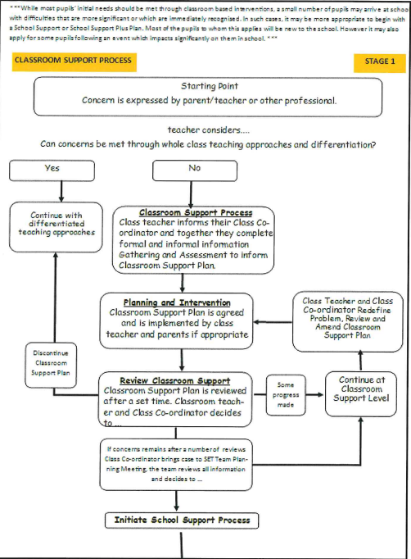

Appendix 2: Flow Diagram – School Support (Stage 2)
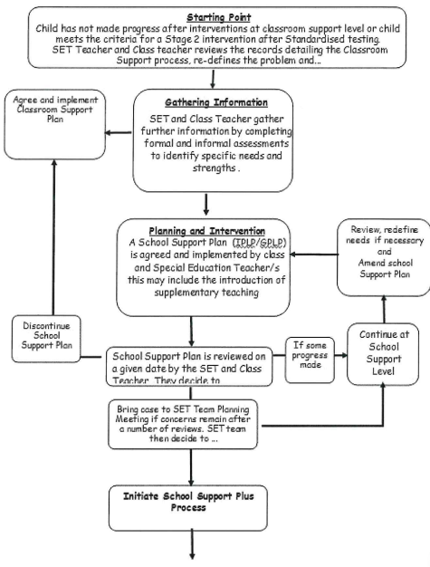

Appendix 3: Flow Diagram – School Support Plus (Stage 3)
