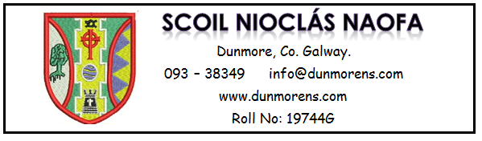
16.11.2018
Dear Parent/Guardian,
Our school is delighted to announce that we will shortly roll out the Aladdin Schools Connect to parents/guardians of children in our classes.
The school uses the Aladdin Schools software service www.aladdin.ie for administrative purposes and Connect will give you secure access to messages from the school and to details of your child’s attendance, test results, reports cards etc via secure login from your internet browser or Aladdin Connect App.
You can rest reassured that Aladdin Schools uses state-of-the-art security to safeguard information entered by the school and data is stored and processed in strict compliance with Irish and European data protection laws.
In the next few days, you will receive a text/email message through Aladdin containing your registration link.
There will be one link per parent which will allow the parent to access information for all their children in the school from one user account.
Please do not forward this text/email or share this link as this is a unique registration code for each parent for your child/children in this school. During registration you must choose a unique personal password that will be used in conjunction with your email address to securely access the Aladdin Connect going forward.
Once you are registered you will be sent an email with links to download the Aladdin Connect App for your mobile device. The main advantage of using the App is to receive immediate alerts for app messages sent by your school. Downloading the App is highly recommended to enhance both the parent and school's Connect experience. This is a FREE APP and all costs are covered by the school.
Your contact information already supplied to us (ie email address and SMS text messaging number) will be incorporated into the Aladdin Connect system, therefore communication should be as seamless as before.
In preparation for this please let the school know via email if your email address or phone number have changed recently.

Aladdin Connect is a fantastic way to enhance a school's communication with parents. It enables parents to stay connected and informed about their child's education by:
- Ensuring that the school has their most up to date contact information
- Keeping parents apprised of their child's attendance
- Keeping parents up to date on school and classroom news via noticeboard messages
- Allowing parents view their child's approved report card as and from June, 2019
- Allowing parents to view their child's latest standardised test results.
Along with strengthening our home/school partnership, we also envisage Aladdin Connect helping the school by:
- Helping to improve attendance by allowing parents to keep track of any school days their child may have currently missed, along with late arrival and early leaving information.
- Helping to reduce the amount of class/school notes being sent home
- Helping the school/ teachers communicate with parents when the need arises
- Reducing costs by eliminating the need to send school report cards by post
- Reducing costs by reducing the number of text messages that need to be sent
We hope that you enjoy using Aladdin Connect. Your class teacher, Fidelis or myself will welcome any feedback or questions you may have.

Yours sincerely,

Principal

